### **CapProj1 Mini-Proj: Exploratory Data Analysis - Inferential Statistics Report**

* Initial Analysis:

We see from our analysis of the data that indeed each variable has some value of correlation to the compared variable RPM. Most values that are expected to have a strong correlation to RPM such as points and assists do in fact have a high correlation coefficient. However, some values counterintuitively have high correlation coefficients such as turnovers (which decreases offensive impact and likely increases defensive impact negatively). These trends are most likely the cause of many variables acting simultaneously.

*Plot 1 (below-left): Box-Pot of RPM by Position (all years)*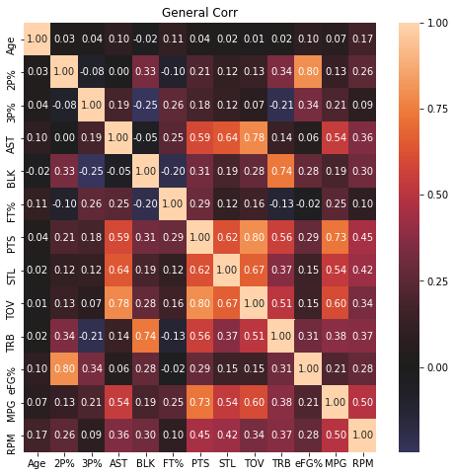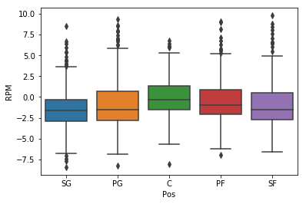

*Plot 2 (right): Correlation Matrix of all variables against RPM (all years)*

* Primary Plot Analysis:

RPM is a good unbiased tool to evaluate players comparatively versus one another, but the process of evaluation occurs first within the team. A player’s RPM should be not be directly compared to a player from another team until the quality of the team as a whole is taken into consideration first. Additionally, in the first plot, we can see that RPM also differs between positions. To understand this skewness, we must analyze our data by separating players by position and to seeing which variables are more or less impactful than the general model with accounts for all the positions.

* Insights of Primary Plots / Further Analysis / Additional Visuals: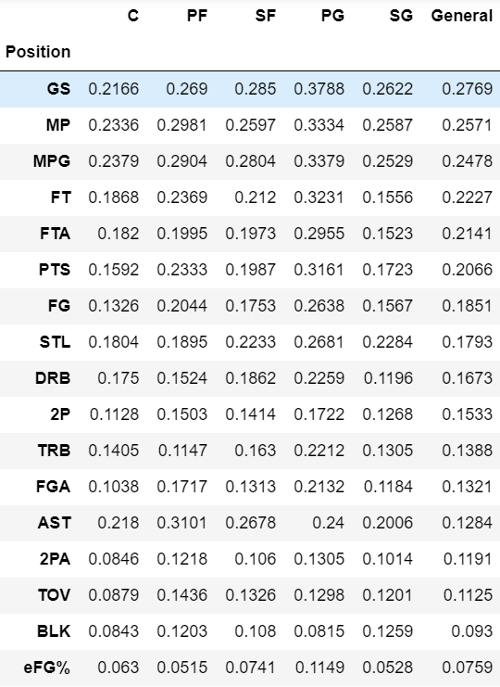

The end goal is to create a best-fit model that accurately predicts RPM. To do that and be able to see clear connections, we must strip away unrelated information and adjust the related information in a way that can be understood. From our analysis above of the primary plots, we know that we must first strip away the unrelated variables. By sorting these variables by their r-squared values (the variable’s correlation to RPM) and using their p-value (in this case whether the relationship is statistically significant), we can determine which variables we should use. In the chart to the left, the variables are sorted by their r-squared value for all positions and given value zero (0) if insignificant (p-value greater than 0.01).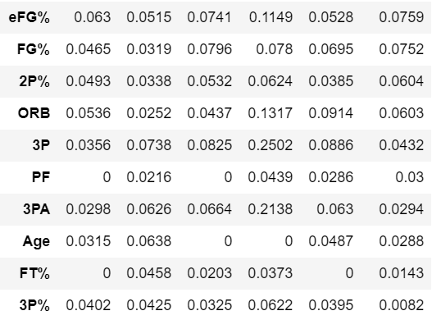

From this chart we now know which variables have relevance. To create a good model, we must use the right combination of variables to produce the most accurate prediction of what RPM is based on those variables. For most of the variables, the general model has an r-squared value averaging somewhere close to and between the values for each position. A general model would in those cases be sufficient to describe them. But if we look at assists (AST), we see that all the r-squared values are higher for each position than the general model. If we look back at the scatter plot of ‘AST’ and ‘RPM’, we can see the data is much different for each position. Therefore, we need to keep in mind, during model testing, which variables must be evaluated separately and which ones can follow a general analysis. During the model testing process, we see that the more variables we have in our model, the higher the correlation is to the RPM data. But that is merely because the model is from one dataset, and having more variables just means the model can describe itself better. To be able to predict future RPM accurately, we must determine which variables have a direct impact.

To determine which variables to use, we initially include all the variables in our model. The model will initially contain variables that are redundant (Multicollinearity). To get the right combination of variables for our model, we have to determine which of these variables are redundant of one another. Then one group of redundant variables at a time, only use the variable with highest correlation. Using the Variance Inflation Factor (VIF), we can determine which variables are likely correlated to one another. Variables with higher VIFs are likely related in this way. When you systematically remove one variable, every other variable’s VIF value decreases, significantly more so for the variable related to the removed variable. For example, the variables “PTS” (points), “FG” (field-goals), “2P” (two-pointers) and “3P” (three-pointers) all describe scoring two/three points for a made basket for that individual. These are essentially combinations of the same thing. We then leave only one variable in the model, that which has the highest correlation, in this case “PTS”. After repeating this process, we get a model without insignificant or redundant independent variables (highest r-squared first).

RPM ~ GS + MPG + FT + PTS + STL + DRB + AST + TOV + BLK + eFG%

...progress as of 1/29/18